Vyskan
Product Name | 4G LTE High-Capacity Anti-Tamper Tracker
Product Model | VN05
Rugged. Covert. Enduring.
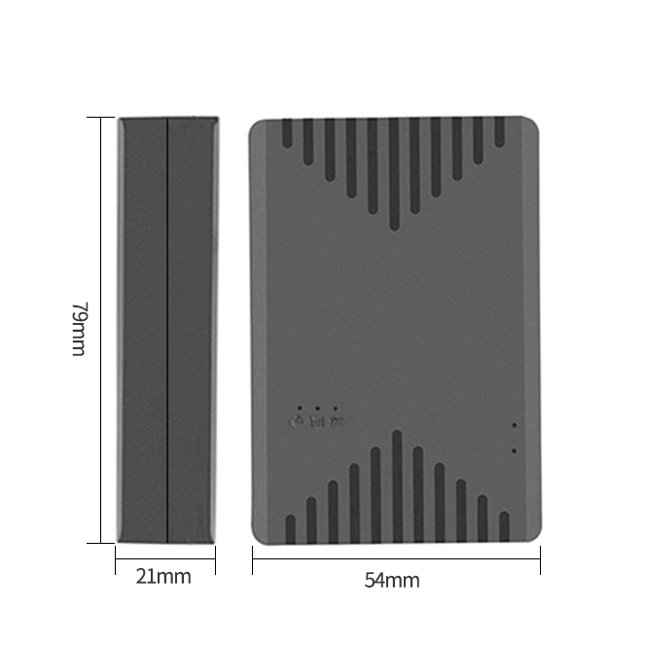
Engineered specifically for long-term asset monitoring and optimized for globle network frequencies, the Vyskan VN05 is a heavy-duty 4G LTE wireless positioning terminal. It houses a massive 5000mAh battery within a highly durable, IP65-rated covert enclosure. Integrating multi-constellation GPS/BDS tracking, a built-in 3-axis accelerometer, and a highly sensitive optical light sensor for instant tamper alerts, it delivers uncompromising, wire-free security for auto finance, enterprise fleets, and high-value cargo over extended operational periods.
- Core Value
- Extended 5000mAh Endurance
The massive internal battery, combined with three dynamic smart-power modes, delivers exceptional standalone operational life. This drastically reduces the frequency of field retrievals for charging, lowering overall fleet maintenance costs.
- Proactive Optical Tamper Defense
An integrated optical sensor acts as a proactive security shield. If the device is maliciously detached or exposed to light, it triggers an instant alarm upload to the platform, securing high-risk leased or financed assets.
- Zero Data Loss Guarantee
Built-in large-capacity flash memory automatically caches vehicle trajectory data when entering cellular blind spots. Once the network recovers, the data is seamlessly re-uploaded, ensuring fleet managers never lose critical operational history.

- Target Applications
- Auto Finance & Credit Risk: (The covert wire-free design and instant optical removal alarms provide uncompromised anti-theft monitoring for high-risk leased vehicles over extended periods).
- Enterprise Fleet & Car Rentals: (Vibration alerts, over-speed detection, and offline data caching ensure managers have complete, uninterrupted visibility of vehicle behavior without draining the vehicle's own battery).
- High-Value Cargo & Logistics: (The high-capacity 5000mAh battery and IP65 rugged design make it the perfect standalone tracker for non-powered assets and long-haul shipments).
- Technical Specifications
  - Cellular & GNSS
Category | Specification | Description
Network Bands | 4G LTE-FDD  & 2G GSM | LTE-FDD(Optional): B1/B2/B3/B4/B5/B7/B8/B28/B66;  GSM: 850/900/1800/1900MHz.
Positioning Mode | BDS + GPS | Dual-constellation tracking ensures highly accurate visibility across diverse terrains.
Startup Time | Cold: Avg 32s | Hot: Avg 1s | Rapid Time-To-First-Fix (TTFF) for instant location acquisition upon deployment.
Sensitivity | -162 dBm | Maintains strong satellite lock via an anti-interference ceramic antenna.
  - Power & Electrical
Category | Specification | Description
Battery Capacity | 5000 mAh | Massive internal battery designed for long-term, standalone asset tracking.
Working Voltage | DC 3.4V - 4.5V | Stable internal electrical architecture.
Working Current | Avg 40mA @ 4V | Highly efficient power utilization during active data transmission.
Sleep / Standby | Sleep: Avg 6mA | Standby: Avg 60uA | Industry-leading deep sleep architecture to maximize field longevity.

  - Interfaces & Expandability
Category | Specification | Description
Anti-Tamper | Optical Sensor | Instantly detects environmental light to trigger removal alerts.
Motion Sensor | 3-Axis Accelerometer | Enables intelligent wake-up, vibration alarms, and over-speed detection.
Data Interface | Flash Storage | Caches data during cellular drops for seamless upload upon reconnection.
  - Physical & Environmental
Category | Specification | Description
Dimensions | 78mm × 54mm × 21mm | Compact, robust design easily adaptable for stealthy vehicle or cargo deployment.
Weight | 132g (Host) | Substantial yet highly deployable ABS plastic construction.
IP Rating | IP65 | Resists dust ingress and water, ensuring durability in harsh outdoor conditions.
Operating Temp. | -20℃ to 75℃ | Robust industrial-grade resilience in diverse climates.
- Deployment & Integration
Zero-Wiring Deployment & Seamless Integration: The VN05 is designed for immediate, wire-free concealment. Featuring a self-ejecting Nona SIM card slot, it allows for rapid, tool-free field preparation. It seamlessly integrates into existing fleet software architectures using standard TCP/IP data transmission via domain or IP address. Furthermore, it fully supports Over-The-Air (OTA) remote firmware upgrades and parameter configuration, completely eliminating the need for physical device retrieval during maintenance cycles.
- A personalized service prepared for you
- 1× VN05 Sample Device (Pre-configured)
- Full API & Protocol Documentation
- on-1 Technical Support from our Field Engineers
- Contact us
Website：https://Vyskan.com/
Email: contact@Vyskan.com | support@Vyskan.com

